**Edifier Speaker Set**

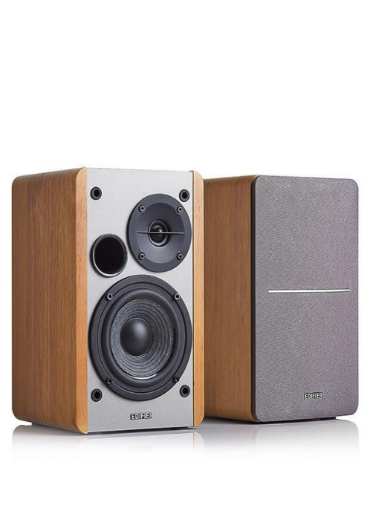

**Key Features  
  
 THX Certified audio  
 400 watts powerful sound  
 Supports multiple inputs simultaneously  
 Optical, 3.5 mm & RCA inputs  
 Subwoofer: 130 W  
 Satellites: 2 x 35 W  
 Price per Unit: $150/-**

**CORPORATE OFFICE**

    1300 E. Control Tower Rd.  
    Suite 216 Block L3  
    Englewood CO 80112  
 Phone: 720.974.7878  
    Toll Free: 1.877.929.7878  
    Email: [info@choicescreening.com](mailto:info@choicescreening.com)